CO4_AT1_DATA INTERPRETATION
Course code:ITA0506 Karanam Meghana
Course Name: Computer vision 192321126
1. Real-Time Detection System
The three object detection methods are Viola-Jones, YOLO, and Deep Learning. They differ in terms of accuracy and processing speed.
Method | Accuracy | Speed
Viola-Jones | 78% | Fast
YOLO | 92% | Moderate
Deep Learning | 95% | Slow
Viola-Jones:
Viola-Jones is a fast object detection technique and is suitable for systems with limited computational resources. However, its accuracy is only 78%, which means it may produce more false detections and miss some objects. It is suitable when speed is more important than detection accuracy.
YOLO:
YOLO provides 92% accuracy with moderate processing speed. It can detect objects quickly while maintaining high accuracy. It is widely suitable for real-time applications because it provides a good balance between speed and accuracy.
Deep Learning:
Deep Learning provides the highest accuracy of 95%. It can handle complex objects and different environments better. However, it is slow compared with the other methods and generally requires more computational resources. Therefore, it may introduce higher latency.
Evaluation:
For a surveillance system operating under strict latency constraints, YOLO is the most suitable method. Although Viola-Jones is faster, its accuracy is considerably lower. Deep Learning has slightly better accuracy than YOLO but is slow.
Deployment Conditions:
In a real-time surveillance system, cameras continuously capture video, so the detection system must respond quickly. A small delay can reduce the effectiveness of surveillance. Therefore, the system needs both acceptable accuracy and low latency.
Conclusion:
YOLO should be selected because it provides 92% accuracy with moderate speed. It offers the best practical balance between detection accuracy and real-time performance. Viola-Jones can be selected for highly resource-constrained systems, while Deep Learning is preferable when accuracy is more important than latency.

2. Robust Object Detection
Object detection systems must work reliably under different environmental conditions such as normal lighting, occlusion, and low-light situations.
Method | Normal | Occlusion | Low Light
Viola-Jones | 80% | 60% | 55%
YOLO | 90% | 75% | 70%
Deep Learning | 95% | 85% | 80%
Viola-Jones:
Under normal conditions, Viola-Jones provides 80% accuracy. However, its performance decreases to 60% when objects are partially blocked and further decreases to 55% under low-light conditions. This shows that it is less robust in difficult environments.
YOLO:
YOLO performs better than Viola-Jones in all conditions. It achieves 90% accuracy under normal conditions, 75% with occlusion, and 70% in low light. Therefore, YOLO provides better robustness while still being suitable for relatively fast detection.
Deep Learning:
Deep Learning achieves the highest performance in all three conditions. It gives 95% accuracy under normal conditions, 85% under occlusion, and 80% in low-light environments. The smaller reduction in performance indicates better robustness.
Comparison:
Deep Learning > YOLO > Viola-Jones in terms of overall robustness.
The average accuracy can also be considered:
- Viola-Jones = (80 + 60 + 55) / 3 = 65%
- YOLO = (90 + 75 + 70) / 3 = 78.33%
- Deep Learning = (95 + 85 + 80) / 3 = 86.67%
Therefore, Deep Learning has the highest overall average performance.
Trade-offs:
- Viola-Jones requires fewer resources and is fast, but its robustness is low.
- YOLO provides a good balance between speed, accuracy, and robustness.
- Deep Learning provides the highest accuracy and robustness but requires greater computational resources and may have higher latency.
Conclusion:
Deep Learning is the best overall method because it performs consistently well under normal, occluded, and low-light conditions. However, if the application has strict real-time or hardware limitations, YOLO may be a better practical choice.

3. Optical Flow Analysis
Optical flow is used to estimate the movement of objects between consecutive frames of a video. The two available methods have different strengths.
Method A
Method A produces stable motion vectors. This means the detected movement is smooth and consistent. It is less affected by noise and provides reliable tracking. However, it may fail to detect small or subtle movements.
Method B
Method B is capable of detecting fine and small movements. Therefore, it can provide more detailed motion information. However, it produces noisy motion vectors, which can reduce tracking stability and may lead to false movement detection.
Comparison
Factor | Method A | Method B
Motion accuracy | Good for large movements | Good for fine movements
Stability | High | Low
Noise sensitivity | Low | High
Small motion detection | Poor | Excellent
Tracking reliability | High | Moderate
Filtering requirement | Low | High
Evaluation
For dynamic scenes, the choice depends on the application. If the main objective is stable and reliable tracking, Method A is more appropriate. Its stable vectors make it useful for tracking vehicles, people, or other objects moving continuously.
Method B is more suitable when the application needs to detect small and detailed movements. For example, it may be useful in gesture recognition or applications where subtle movements are important.
However, because Method B produces noisy vectors, additional filtering or smoothing techniques may be required. This increases processing requirements.
Conclusion
For general motion tracking in dynamic scenes, Method A is more suitable because stability and noise resistance are important for continuous tracking. However, if detecting fine motion is the main requirement, Method B should be selected. Thus, the final choice depends on the application's accuracy and motion-detection requirements.

4. Model Generalization and Overfitting
Model generalization refers to the ability of a machine learning model to perform well on unseen or new data. A model that performs very well on training data but poorly on testing data may suffer from overfitting.
Model | Training Accuracy | Testing Accuracy
A | 98% | 70%
B | 90% | 88%
Model A
Model A has a training accuracy of 98%, which appears very high. However, its testing accuracy is only 70%. The difference between training and testing accuracy is:
98% − 70% = 28%
This is a large gap and indicates that Model A has likely overfitted the training data.
The model may have memorized the training examples instead of learning general patterns. As a result, its performance decreases significantly when it receives new data.
Model B
Model B has a training accuracy of 90% and testing accuracy of 88%.
Difference:
90% − 88% = 2%
This is a very small difference. Therefore, Model B has much better generalization ability and a lower risk of overfitting.
Comparison
Factor | Model A | Model B
Training accuracy | 98% | 90%
Testing accuracy | 70% | 88%
Accuracy gap | 28% | 2%
Overfitting risk | High | Low
Generalization | Poor | Good
Real-world reliability | Low | High
Evaluation
Although Model A has higher training accuracy, training accuracy alone is not sufficient to select a model. Testing accuracy is more important for evaluating how well the model performs on unseen data.
Model B has slightly lower training accuracy but significantly higher testing accuracy. This indicates that it has learned general patterns rather than memorizing the training dataset.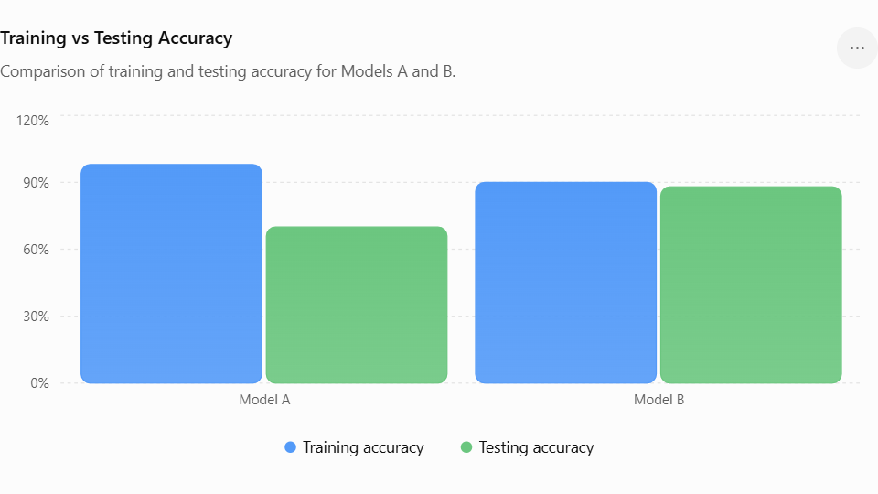
Conclusion
Model B should be selected for real-world deployment. It has an accuracy gap of only 2%, indicating strong generalization and low overfitting risk. Model A should be improved using techniques such as regularization, dropout, data augmentation, or more training data before deployment.

5. System Performance under Constraints
A real-time application requires a proper balance between accuracy, latency, and cost. The three models have the following performance:
Model | Accuracy | Latency | Cost
A | 88% | 50 ms | Low
B | 92% | 80 ms | Moderate
C | 95% | 120 ms | High
Model A
Model A has the lowest latency of 50 ms and low cost. This makes it attractive for real-time applications. However, its accuracy is only 88%. If accurate detection is important, this may not be sufficient.
Model B
Model B provides 92% accuracy with 80 ms latency and moderate cost. It provides a significant improvement in accuracy compared with Model A while maintaining reasonably low latency.
Model C
Model C provides the highest accuracy of 95%, but its latency is 120 ms and cost is high. The 3% improvement in accuracy compared with Model B comes with an additional 40 ms latency and higher deployment cost.
Comparison
Factor | Model A | Model B | Model C
Accuracy | 88% | 92% | 95%
Latency | 50 ms | 80 ms | 120 ms
Cost | Low | Moderate | High
Real-time suitability | Excellent | Very good | Lower
Overall balance | Good | Best | Expensive
Evaluation
For a real-time application, very high accuracy is not the only requirement. The system must also respond quickly and operate within the available budget.
Model A is fastest and cheapest, but its accuracy is lower. Model C provides the highest accuracy, but its high latency and cost may make it unsuitable for strict real-time applications.
Model B provides the best compromise. It improves accuracy from 88% to 92% compared with Model A, while its latency remains relatively low at 80 ms.
Conclusion
Model B is the best choice for a real-time application because it provides the best balance between accuracy, latency, and cost. Model A can be chosen when minimum latency and cost are the highest priorities, while Model C can be chosen when maximum accuracy is more important than cost and latency.

